# 20200702
# https://jira.tcsbank.ru/browse/IN-311
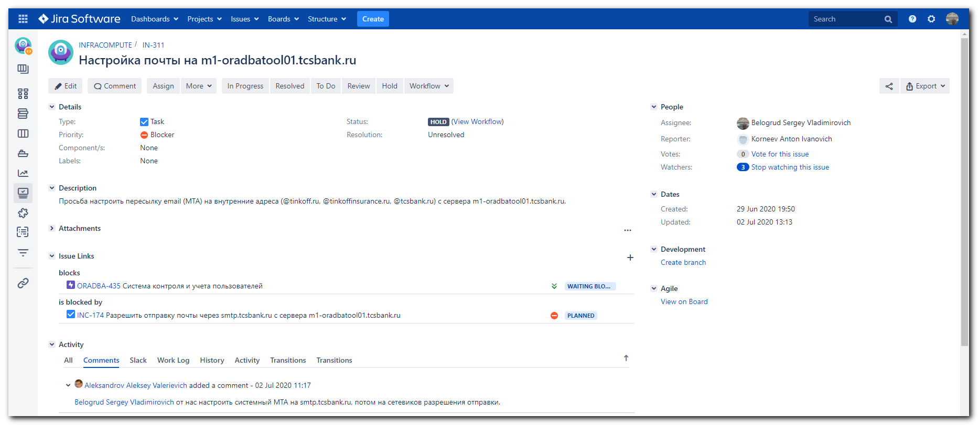
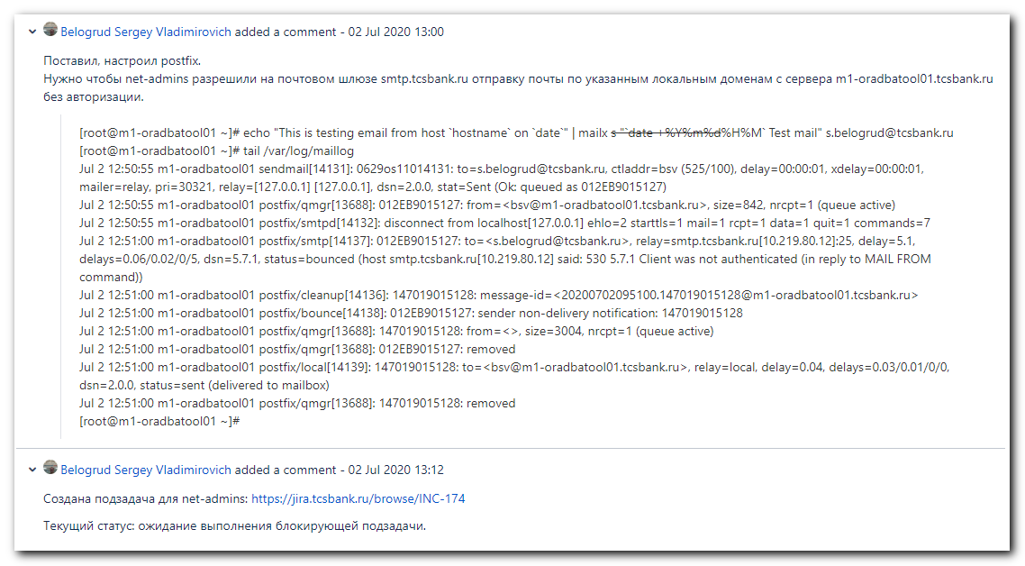

................................................................................

#
# https://jira.tcsbank.ru/browse/IN-311
# Настройка почты на m1-oradbatool01.tcsbank.ru
#
[root@m1-oradbatool01 ~]# cat /etc/os-release
NAME="CentOS Linux"
VERSION="8 (Core)"
ID="centos"
ID_LIKE="rhel fedora"
VERSION_ID="8"
PLATFORM_ID="platform:el8"
PRETTY_NAME="CentOS Linux 8 (Core)"
ANSI_COLOR="0;31"
CPE_NAME="cpe:/o:centos:centos:8"
HOME_URL="https://www.centos.org/"
BUG_REPORT_URL="https://bugs.centos.org/"

CENTOS_MANTISBT_PROJECT="CentOS-8"
CENTOS_MANTISBT_PROJECT_VERSION="8"
REDHAT_SUPPORT_PRODUCT="centos"
REDHAT_SUPPORT_PRODUCT_VERSION="8"

[root@m1-oradbatool01 ~]#

[root@m1-oradbatool01 ~]# yum install postfix
[root@m1-oradbatool01 ~]# yum install mailx

[root@m1-oradbatool01 ~]# grep -e "^myhostname" -e "^mydomain" -e "^myorigin" -e "^inet_protocols" -e "^relayhost" /etc/postfix/main.cf
myhostname = m1-oradbatool01.tcsbank.ru
mydomain = tcsbank.ru
myorigin = $myhostname
inet_protocols = ipv4
relayhost = [smtp.tcsbank.ru]
[root@m1-oradbatool01 ~]#

[root@m1-oradbatool01 ~]# systemctl status postfix
● postfix.service - Postfix Mail Transport Agent
Loaded: loaded (/usr/lib/systemd/system/postfix.service; disabled; vendor preset: disabled)
Active: inactive (dead)
[root@m1-oradbatool01 ~]#

[root@m1-oradbatool01 ~]# telnet smtp.tcsbank.ru 25
Trying 10.219.80.12...
Connected to smtp.tcsbank.ru.
Escape character is '^]'.
220 ds-msk-mail1301.tcsbank.ru Microsoft ESMTP MAIL Service ready at Thu, 2 Jul 2020 12:44:11 +0300
^]quit

telnet> quit
Connection closed.
[root@m1-oradbatool01 ~]#

[root@m1-oradbatool01 ~]# systemctl start postfix
[root@m1-oradbatool01 ~]# systemctl status postfix
● postfix.service - Postfix Mail Transport Agent
Loaded: loaded (/usr/lib/systemd/system/postfix.service; disabled; vendor preset: disabled)
Active: active (running) since Thu 2020-07-02 12:44:45 MSK; 5s ago
Process: 13610 ExecStart=/usr/sbin/postfix start (code=exited, status=0/SUCCESS)
Process: 13608 ExecStartPre=/usr/libexec/postfix/chroot-update (code=exited, status=0/SUCCESS)
Process: 13603 ExecStartPre=/usr/libexec/postfix/aliasesdb (code=exited, status=0/SUCCESS)
Main PID: 13686 (master)
Tasks: 3 (limit: 23596)
Memory: 6.1M
CGroup: /system.slice/postfix.service
├─13686 /usr/libexec/postfix/master -w
├─13687 pickup -l -t unix -u
└─13688 qmgr -l -t unix -u

Jul 02 12:44:45 m1-oradbatool01.tcsbank.ru systemd[1]: Starting Postfix Mail Transport Agent...
Jul 02 12:44:45 m1-oradbatool01.tcsbank.ru sendmail[13605]: alias database /etc/aliases rebuilt by root
Jul 02 12:44:45 m1-oradbatool01.tcsbank.ru aliasesdb[13603]: /etc/aliases: 76 aliases, longest 10 bytes, 771 bytes total
Jul 02 12:44:45 m1-oradbatool01.tcsbank.ru sendmail[13605]: /etc/aliases: 76 aliases, longest 10 bytes, 771 bytes total
Jul 02 12:44:45 m1-oradbatool01.tcsbank.ru postfix/master[13686]: daemon started -- version 3.3.1, configuration /etc/postfix
Jul 02 12:44:45 m1-oradbatool01.tcsbank.ru systemd[1]: Started Postfix Mail Transport Agent.
[root@m1-oradbatool01 ~]#

[root@m1-oradbatool01 ~]# systemctl enable postfix
Created symlink /etc/systemd/system/multi-user.target.wants/postfix.service → /usr/lib/systemd/system/postfix.service.
[root@m1-oradbatool01 ~]#

[root@m1-oradbatool01 ~]# mailq
/var/spool/mqueue is empty
Total requests: 0
[root@m1-oradbatool01 ~]#

[root@m1-oradbatool01 ~]# echo "This is testing email from host `hostname` on `date`" | mailx -s "`date +%Y%m%d-%H%M` Test mail" s.belogrud@tcsbank.ru
[root@m1-oradbatool01 ~]# tail /var/log/maillog
Jul 2 12:50:55 m1-oradbatool01 sendmail[14131]: 0629os11014131: to=s.belogrud@tcsbank.ru, ctladdr=bsv (525/100), delay=00:00:01, xdelay=00:00:01, mailer=relay, pri=30321, relay=[127.0.0.1] [127.0.0.1], dsn=2.0.0, stat=Sent (Ok: queued as 012EB9015127)
Jul 2 12:50:55 m1-oradbatool01 postfix/qmgr[13688]: 012EB9015127: from=<bsv@m1-oradbatool01.tcsbank.ru>, size=842, nrcpt=1 (queue active)
Jul 2 12:50:55 m1-oradbatool01 postfix/smtpd[14132]: disconnect from localhost[127.0.0.1] ehlo=2 starttls=1 mail=1 rcpt=1 data=1 quit=1 commands=7
Jul 2 12:51:00 m1-oradbatool01 postfix/smtp[14137]: 012EB9015127: to=<s.belogrud@tcsbank.ru>, relay=smtp.tcsbank.ru[10.219.80.12]:25, delay=5.1, delays=0.06/0.02/0/5, dsn=5.7.1, status=bounced (host smtp.tcsbank.ru[10.219.80.12] said: 530 5.7.1 Client was not authenticated (in reply to MAIL FROM command))
Jul 2 12:51:00 m1-oradbatool01 postfix/cleanup[14136]: 147019015128: message-id=<20200702095100.147019015128@m1-oradbatool01.tcsbank.ru>
Jul 2 12:51:00 m1-oradbatool01 postfix/bounce[14138]: 012EB9015127: sender non-delivery notification: 147019015128
Jul 2 12:51:00 m1-oradbatool01 postfix/qmgr[13688]: 147019015128: from=<>, size=3004, nrcpt=1 (queue active)
Jul 2 12:51:00 m1-oradbatool01 postfix/qmgr[13688]: 012EB9015127: removed
Jul 2 12:51:00 m1-oradbatool01 postfix/local[14139]: 147019015128: to=<bsv@m1-oradbatool01.tcsbank.ru>, relay=local, delay=0.04, delays=0.03/0.01/0/0, dsn=2.0.0, status=sent (delivered to mailbox)
Jul 2 12:51:00 m1-oradbatool01 postfix/qmgr[13688]: 147019015128: removed
[root@m1-oradbatool01 ~]#

#
# Need to send request to net-admins to allow sending email from this server.
#
# Jul 2 12:51:00 m1-oradbatool01 postfix/smtp[14137]: 012EB9015127: to=<s.belogrud@tcsbank.ru>, relay=smtp.tcsbank.ru[10.219.80.12]:25, delay=5.1, delays=0.06/0.02/0/5, dsn=5.7.1, status=bounced (host smtp.tcsbank.ru[10.219.80.12] said: 530 5.7.1 Client was not authenticated (in reply to MAIL FROM command))
#

[root@m1-oradbatool01 ~]# mailq
/var/spool/mqueue is empty
Total requests: 0
[root@m1-oradbatool01 ~]#

................................................................................

